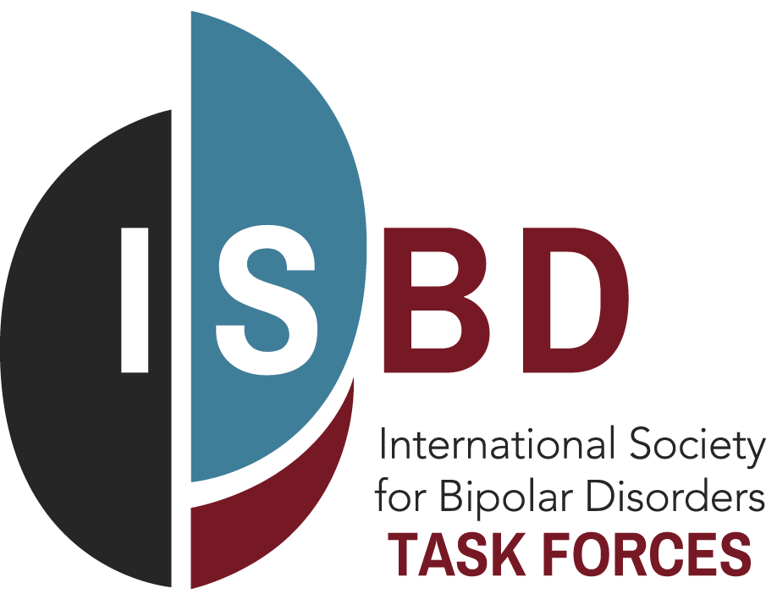
Notice of Manuscript Submission form

To enable the ISBD to facilitate expedited reviews of Task Force papers and to have a transparent process for Open Access requests, please submit the form below two to four weeks prior to submission of your Task Force Manuscript for publication.
Task Force Name:
Task Force Chair(s):
Manuscript Title:
Manuscript Authors:
Anticipated Date of Submission:
Target Journal for Publication:
Requesting Open Access (Yes* or No):
*If requesting Open access, please give a 2-3 line explanation describing how the Manuscript will have broad appeal to the membership of the ISBD, is of critical importance for clinical care of patients suffering from Bipolar Disorder, and/or is a strategic priority of the ISBD. Please note we will not be able to consider manuscripts for Open Access unless this form together with a copy of the manuscript are received by the ISBD prior to submission for peer review.

Please attach a final copy of your Manuscript for submission prepared in accordance with the Guidelines for Manuscript Development

Send all documents to Mary Miller marym@isbd.org
With thanks, the ISBD Executive

