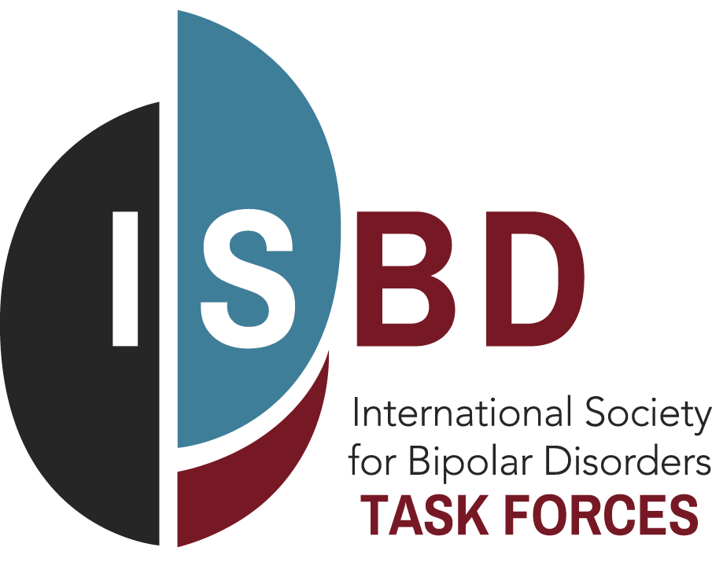
Notice of Task Force Manuscript Submission

To enable the ISBD to facilitate expedited reviews of Task Force manuscripts and to have a transparent process for fairly administering the limited annual budget to support Open Access requests, please submit this form to the ISBD attention Mary Miller marym@isbd.org, ideally two to four weeks prior to submission of your manuscript
Task Force Name:
Task Force Chair(s):
Manuscript Title:
Manuscript Authors:
Anticipated Date of Submission:
Target Journal for Publication*:
*If other than Bipolar Disorder the official Journal for the ISBD, please provide a brief explanation below.

Requesting Open Access Fee subsidy from ISBD (Yes** or No):
**If requesting Open access fees subsidy, please give a 2-3 line justification describing for example how the manuscript will have broad appeal to the membership of the ISBD, is of critical importance for clinical care of patients, and/or is a strategic priority of the ISBD. The ISBD encourages authors to take advantage of existing Open Access Fee exemptions through their affiliated institutions before making a request to the ISBD. As per the Guidelines for Requesting Open Access Fees, fee subsidy will only be considered for submissions to Bipolar Disorders, the official Journal of the ISBD.

Please attach a final copy of your Manuscript for submission prepared in accordance with the Guidelines for Manuscript Development and the Guidelines for Requesting Open Access Fees and send all documents to Mary Miller marym@isbd.org.
With thanks and appreciation for advancing the ISBD Mission
VP of Research and Executive Committee of the ISBD

